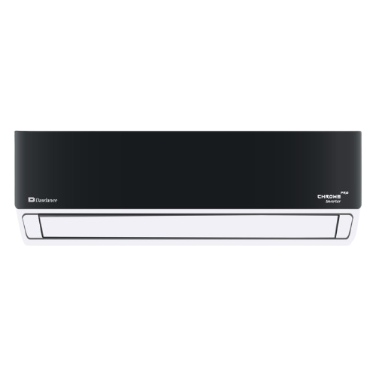****

**THANK YOU!**

SKU: DSU-18HFMCC/013WUSDC (W)

**Dawlance Inverter Split AC Chrome Pro 30 WB 1.5 Ton**

~~Rs 175,999.00~~ Rs 164,000.00

AC Inverter Mono Split

Cooling Capacity 18000 BTU/h

Self Cleaning

With adoption of optimized cooling system, the cooling capacity of Haier Air Conditioners still could catch up 100% to provide the best cooling experience to user at 46◦C high temperature.

**Product details**

**WELLCOME TO OUR WEBSITE**